Spring 2018 Physics Research:

Dynamic Light Scattering on Engine Oil Additives

ABSTRACT

This semester’s research has been focused on two specific copolymers that are additives to engine oil. Specifically, we have utilized dynamic light scattering techniques to study and characterize the aggregates formed by these copolymers in solution. The two polymers differ in that one has a functionalized group attached to the chain, and it is expected that the addition of the group will change how the polymer behaves in a solution of base oil. To better understand aggregation at the molecular level, as well as the results of light scattering experiments, I have studied soft matter physics and self-assembly. This paper contains an overview of relevant principles from self-assembly, soft matter physics, and light scattering theory. It details the methods used in this research, as well as preliminary data and hypotheses for what that data may mean about the polymers. This paper is intended to be more of a progress report about the status of the research project rather than a conclusive report, so the paper ends with a discussion of the results as well as plans for the continuation of this research.

INTRODUCTION

In order to understand the results of light scattering experiments, it is first necessary to understand the physics of how molecules behave in solution. This introduction will cover Brownian motion, self-assembly, and polymer physics before moving on to a discussion of light scattering.

Brownian motion describes the relative movement of various particles in solution. All particles in a system move randomly at speeds dictated by the temperature of the solution. As a result of this motion, there are many collisions between the large and small particles. Collisions with the smaller particles accelerate the larger particles, which then move in “random walks,” paths comprised of movements in any direction with varying magnitudes. The Stokes-Einstein equation, shown below on the left, can be used to obtain the diffusion coefficient, D, where $k_{b}$ is the Boltzman constant, T is temperature, $η$ is viscosity, and r is the radius of the particle:

$D=\frac{k_{b}T}{6πηr}$ $λ={(2Dt)}^{1/2}$

The diffusion coefficient is related to $λ$, the estimated square of the displacement of the particle at time *t*. These two equations play an important role in dynamic light scattering.[1]

Polymers experience the effects of Brownian motion in a slightly different way than the random walks mentioned above. Polymers are chains composed of monomers, single units that are specific combinations of atoms. Copolymers are comprised of multiple different monomers either repeated randomly or in a set pattern. The polymer we are studying is a “block” copolymer, meaning that one type of monomer is repeated, followed by another set of repeated monomers, forming two separate “blocks.” The chemical structure of a polymer can typically be represented as a straight, rod-like particle; however, a more nuanced model of polymer shape and size is necessary to understand how polymers behave in solution.[2]

A polymer can be visualized as a repeating chain of rigid rods, where each monomer rod is flexibly jointed to the adjacent rods, allowing the entire chain to arrange itself in countless ways. When collisions occur between polymers and smaller particles in the solution, the freely jointed segments of the polymer chain move in random ways, so the “random walk” is more accurately described as a random arrangement:

**R**

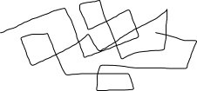

*Figure 1: End-to-end vector R for polymer in solution*

R is the vector whose magnitude is the distance from one end of the polymer chain to the other. R is proportional to $N^{v}$, where N is the number of segments and v is some scaling exponent specific to the solvent.[3] Estimating this end-to-end distance R may be difficult at higher concentrations, because as concentration increases the polymers will tend to wrap around each other. Only at very low concentrations will they avoid contact with each other. A brief overview of the basics of self-assembly will aid in understanding how these polymers arrange both by themselves and in the presence of other polymers.

There are two opposing forces that dictate how particles arrange themselves in solution. The particles are attracted to themselves due to Van der Waals forces, but they are also repelled when they collide. In the case of polymers, the links of the chain are attracted to other links, but the links cannot occupy the same space at the same time, so collisions result. The guiding principle behind self-assembly is that the system will tend toward a state of maximum entropy, as dictated by the second law of thermodynamics. The self-assembled structures will maximize entropy. Change in entropy is proportional to temperature, so self-assembled structures can look different at different temperatures.

The specific type of assembly that this polymer may exhibit is the formation of micelles, which are formed by surfactants in solution. Surfactants have one end that is hydrophobic, meaning it repudiates water molecules, and one end is hydrophilic, meaning that it is attracted to water molecules. The behavior of surfactants in water is dictated by concentration. At low concentrations, the surfactant will form a layer at the surface (hence ‘surfactant’), with the hydrophilic end in the water and the hydrophobic end exposed to the air. At higher concentrations, when there are too many surfactant particles to solely form a surface layer, the surfactants will arrange themselves into micelles. An easily understandable micellar structure is a sphere:

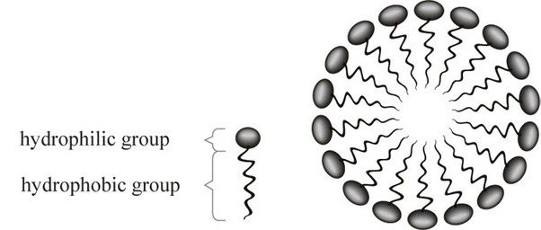

*Figure 2: Spherical micelle*[4]

In micelles, the hydrophilic groups form a shell that protects the hydrophobic ends from exposure to the water. In addition to spheres, cones, cylinders, inverted cones, and other shapes can be formed, depending on the geometry of the surfactant. An important value to obtain for a given surfactant in a certain solution is the critical micelle concentration (CMC), the concentration at which micelles form.[5]

This research is concerned with the behavior of polymers in oil solutions. As mentioned, these are block copolymers, and therefore have one block on one side, and one block on the other. One block end is polystyrene, a molecule composed of hydrogens and carbons, which is hydrophobic. We hypothesize that the other block end, a polyisoprene/butadiene with an added amine group, is hydrophilic. Although polyisoprene is hydrophobic, we guess that the added group will change the behavior of the block. It is expected that the hydrophobic end of the polymer will form a shell around the hydrophilic end, the opposite of what would occur in water. In order to detect the formation of micelles, one can measure particle size and dispersity at differing concentrations, and at a certain concentration (the CMC), a change in particle size and dispersity in expected. Dynamic light scattering (DLS) is a technique that can be used to make these measurements

The theory of DLS is derived largely from the ideas of Brownian motion. In its most basic form, light scattering involves emitting a laser beam that passes through a sample, and then detecting how the light is reflected off the sample. On an atomic level, the oscillating beam of light induces an oscillating dipole in the molecules. The molecules emit electromagnetic radiation, and the intensity of the radiation is measured by a photon detector. It is expected that the particles will move about randomly due to Brownian motion, and so this intensity signal will fluctuate.

The DLS instrument derives particle size from fluctuating intensity signals using an autocorrelation function. This function compares each successively received intensity signal to the initial signal. As would be expected from Brownian motion, the similarity between signals should decrease as the particles move randomly. When a DLS measurement is taken, a computer program uses the data given by the measured intensity fluctuations to fit an exponentially decaying function:

g1(q,τ)=exp(−Γτ)

with τ being the time delay, and the decay rate Γ being equal to q2D, with q representing the magnitude of the scattering vector, and D representing the diffusion coefficient.

The hydrodynamic radius *r* can then be extracted from the Stokes-Einstein Equation:[6]

The Methods section of this paper will discuss how DLS data can be analyzed. Coupled with knowledge of how polymers behave in solution, DLS data analysis tools can give valuable information on the formation of aggregates.

METHODS

This section will discuss the methods used for DLS data analysis and sample preparation of the two polymers that we are interested in. The samples were prepared in a way as to make DLS measurements as accurate as possible.

The two polymers that are the focus of this research differ in that one has a functionalized group attached to the chain, and the other does not. The samples are block copolymers with a hydrogenated polystyrene block and a polyisoprene/butadiene block. From here on, the polymer that has a functionalized group attached to the chain will be referred to as 039-5, and the polymer that does not have a functionalized group will be referred to as 039-2. The solvent for these samples is a base oil whose viscosity is 28.4 mP/s.

In order to dissolve the polymer in the oil, we mixed tetrahydrofuran (THF) into the solution of the polymer sample and oil. The utility of the THF is that it has the ability to dissolve the polymer samples, but it can be evaporated from the sample after the dissolution, leaving only the polymer and the oil. We used a rough ratio of about between 30-50g THF to 1g of polymer. After the solution of polymer, oil, and THF was prepared, we put the sample on a rotating mixing wheel overnight. When the samples were fully mixed, we began the process of evaporating the THF from the samples.

Two methods proved to be most successful in evaporating the THF: the vacuum oven, and increasing the exposed surface area of the sample. The samples were placed in a vacuum oven overnight at between 40-50 degrees C and then weighed to determine how much THF remained in the sample. Ultimately, it took two nights of this process to get the level of THF in the samples down to about 5% of the initial level. We were unable to get 100% evaporation of the THF, but we determined that such a small level of THF in the sample would not severely alter DLS measurements. We transferred some samples to beakers with wide mouths in order to increase the exposed surface area, which turned out to be the quickest way to accomplish evaporation. For future research, a combination of increasing surface area and using vacuum heat will likely merit the quickest evaporation.

One of the biggest concerns when creating samples for DLS is cleanliness of samples. If there are any particulates, like dust, in the samples, the results from DLS will be seriously altered. Large dust particles have a disproportionate effect on DLS measurements because the scattered intensity from larger particles dominates the intensity measurement. At each stage of sample preparation, all beakers, pipettes, and tools were rid of dust by spraying air on them. We avoided using cleaning products such as ethanol and hexane because a trace of those molecules left on the glass could potentially alter the light scattering data.

The viscosity and the refractive index of the solvent need to be measured to perform DLS. We measured the refractive index using a refractometer, and determined it to be 1.459 (dimensionless). We determined the viscosity of the substance to be 28.4 mP/s using a rheometer.

DLS data gave us two valuable pieces of information about the samples: particle size and sample dispersity. As discussed in the introduction, particle size, or more specifically, hydrodynamic radius, can be derived from fitting the data to an exponentially decaying function.

Here is an example of a measurement from a LUDOX sample. LUDOX is a solution of silica particles suspended in water, and is used to test the DLS machine because of its monodispersity and known particle size.

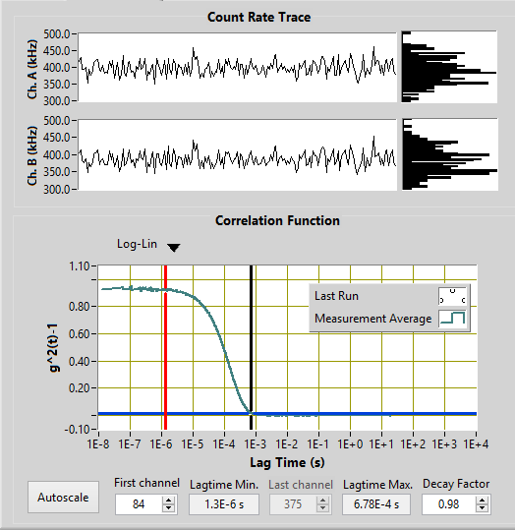

*Figure 3: Autocorrelation function and count rate trace for LUDOX sample*

The first thing to notice about the correlation function curve in this case is its smoothness. Because the exponential decay fit is comprised of the sum of decay fits for various sized particles, the smoothness is an indication of monodispersity. The y-intercept of the fit is related to the signal-to-noise ratio, and high-quality measurements have intercepts close to 1.[7] The two graphs under the “Count Rate Trace” heading show the intensity of signals received over the course of the measurement. Higher intensity in kHz is associated with larger particle size.

From this fit, the DLS software computes an average hydrodynamic radius. The information under “Cumulant Analysis” in Figure 4 shows this radius. Typically the second-order radius is interpreted as the most accurate. The “width” measurement refers to the width of the distribution of particle size, so a smaller width indicates a more monodisperse sample, and a larger width indicates polydispersity. It must be stressed that radius is an *average*, and so large particles will dominate this output. One way of determining whether or not there are multiple particles of differing sizes in the sample is CONTIN analysis.

CONTIN analysis essentially transforms the autocorrelation function into a distribution of particle sizes and relative scattered intensity for each of those sizes. Describing the math behind CONTIN is beyond the scope of this paper, but some analysis of the CONTIN fit is possible without a full understanding of the math. Shown below is the CONTIN fit for the same measurement of LUDOX:

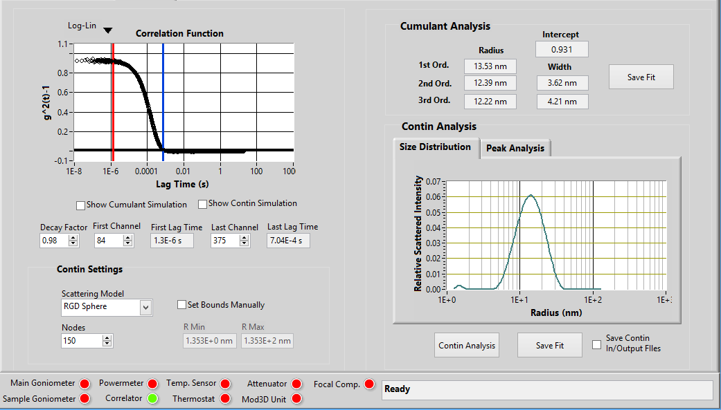

*Figure 4: CONTIN fit for LUDOX sample*

The distribution shown in Figure 4 is what would be expected from a monodispersed sample. If several peaks were present, that would indicate the presence of several populations of particles of varying size. When analyzing CONTIN data, it is important to keep in mind the fact that scattered intensity is not directly proportional to particle size. Scattered intensity is proportional to r^6, with r being the radius of the particle. Therefore larger particles will dominate the intensity reading, and the relative percentages of total intensity from various sized particles must be scaled accordingly.

A final consideration when performing DLS measurements is angular dependence. The DLS machine can perform measurements between 0 and 150 degrees, and output of particle size can be different for varying angles, as shown in Figure 5:



*Figure 5: Hydrodynamic Radius vs. Scattering Angle for 100 ppm Xanthan Gum in H20*

The general trend is that hydrodynamic radius is reported as larger at smaller angles, so it is important to take measurements at various angles, and examine trends. I have chosen to interpret angles between 80-100 degrees to be the most accurate, because large particles will not totally dominate the scattered intensity, but will still be present in the calculations.

RESULTS

DLS Results for the 039-5 (functionalized) polymer

We performed DLS measurements on 039-5 samples in a concentration range of .8% to .001% by weight. The two outputs we were examining closely were dispersity and particle size.

|  |  |  |  |  |
| --- | --- | --- | --- | --- |
| Concentration (% by wt) | Hydrodynamic Radius (nm) | Width (nm) | Average Count Rate (kHz) | Y-axis Intercept |
| 0.8% | 112.02 | 51.39 | 413 | 0.868 |
| 0.6% | 94.44 | 40.94 | 407 | 1.01 |
| 0.4% | 90.04 | 15.22 | 376 | 0.936 |
| 0.2% | 68.71 | 14.88 | 365 | 0.896 |
| 0.1% | 64.3 | 23.88 | 339 | 0.837 |
| 0.05% | 82.12 | 24.32 | 416.5 | 0.853 |
| 0.01% | 84.24 | 15.95 | 115 | 0.949 |
| 0.001% | 66.82 | 13.01 | 14.7 | 0.66 |

*Figure 6: DLS measurement data at 90 degrees scattering angle for concentration range of .001% - .8% for 039-5 samples*

There are several trends of interest in this table. The first is that hydrodynamic radius is slightly larger at higher concentrations, and it begins to fluctuate as the concentration gets lower. Although the radius does not decrease strictly with concentration, the average count rate decreases strictly with only one exception at .05%. The intercepts for all concentrations are in the acceptable range of above .6 and not too far above 1. The width of the distribution is generally, but not strictly, larger at higher concentrations. Figure 7 shows a series of CONTIN analysis plots for the same concentration range:

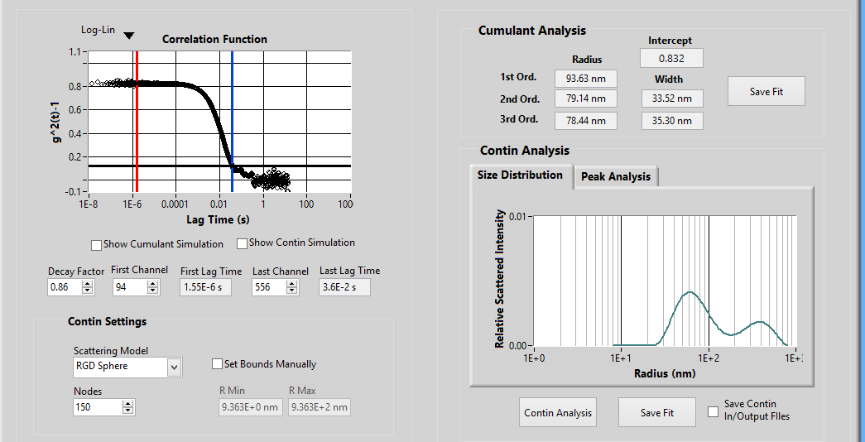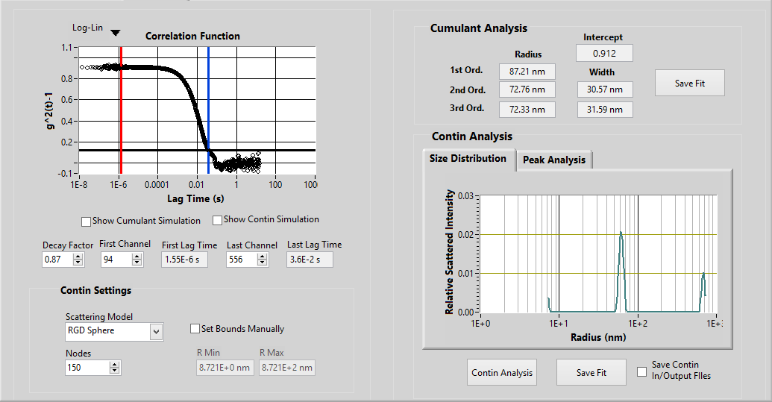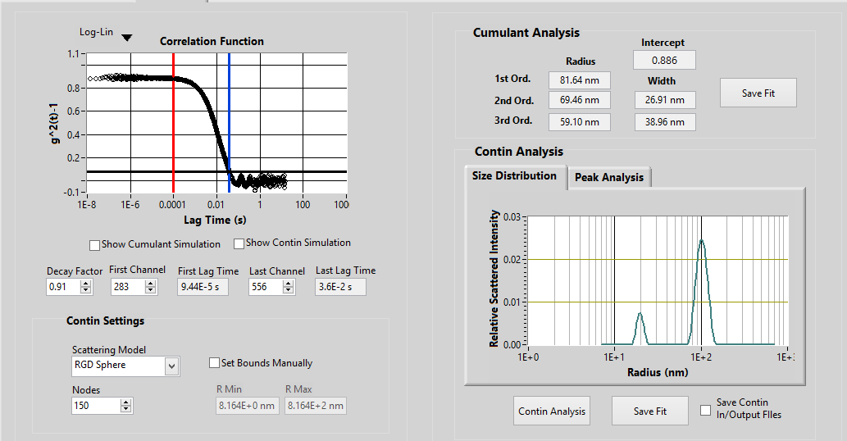

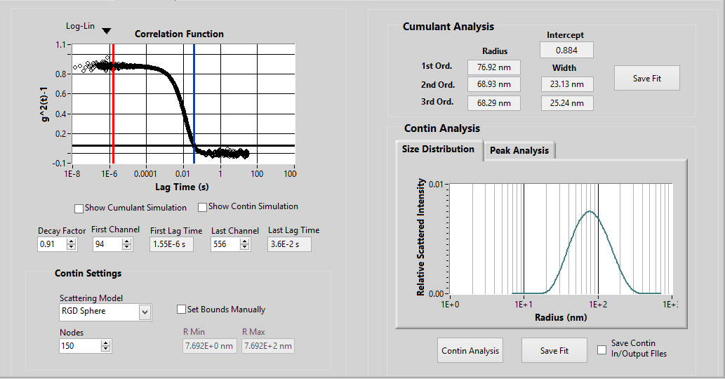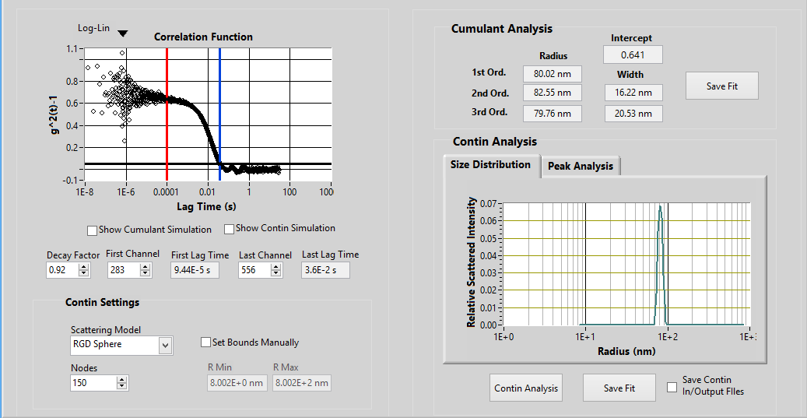

*Figure 7:* *From top left to bottom right: CONTIN analysis plots at 100 degrees scattering angle for .8%, .6%, .1%, .01%, and .001% by weight of 039-5 samples*

The peaks in these graphs can be interpreted as significantly sized populations of particles of a certain size. For example, in the third graph, which corresponds to the .1% sample of 039-5, there is a peak at around 30 nm and a larger one at about 100 nm. The height of the peaks indicates how much of the total intensity received was scattered from that population. However, the proportion of the intensity signal does not correspond directly to the proportion of that population in the sample overall, because intensity is related to size to the sixth power.

Results for the 039-2 (non-functionalized) polymer

We performed DLS measurements on the 039-2 polymer for a concentration range of .001% to 1% by weight. The average count rate for the 039-2 was smaller by at least an order of magnitude than the 039-5 sample:

|  |  |
| --- | --- |
| Concentration (% by wt) | Average Count Rate (kHz) |
| 1% | 24.95 |
| .5% | 8.6 |
| .1% | 5.3 |
| .01% | 6.0 |
| .001% | 3.5 |

*Figure 8: Average count rate in kHz for concentration range of 039-2 samples at scattering angle of 90 degrees*

Such small count rates indicate that the particles in the sample were of a small size. At many angles the DLS software was unable to output a particle size, possibly due to the fact that the waves radiated by the particles were too weak to be picked up by the photon detector. The intercepts for these measurements were often lower than .6, meaning that the fits were not totally reliable.

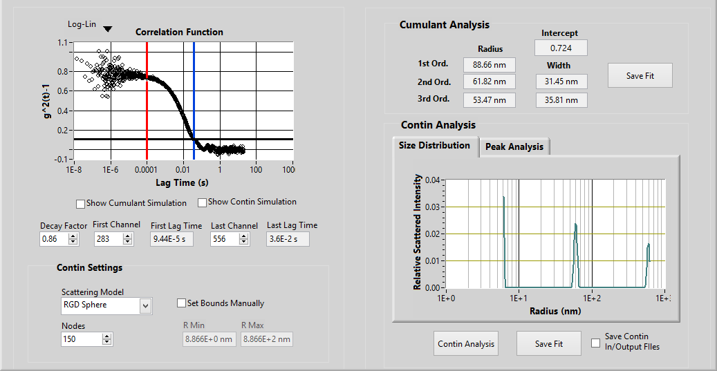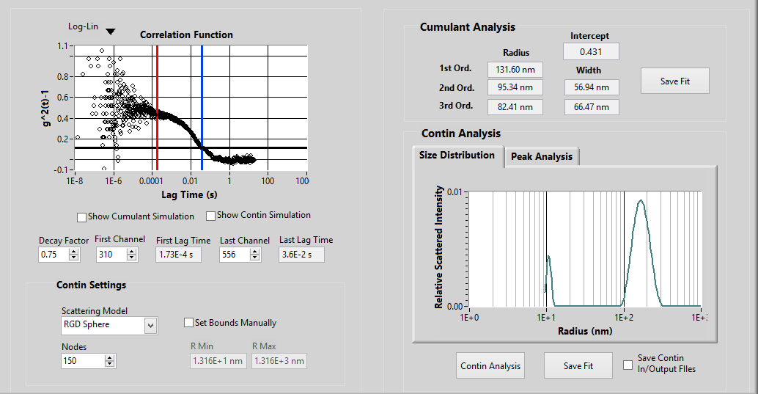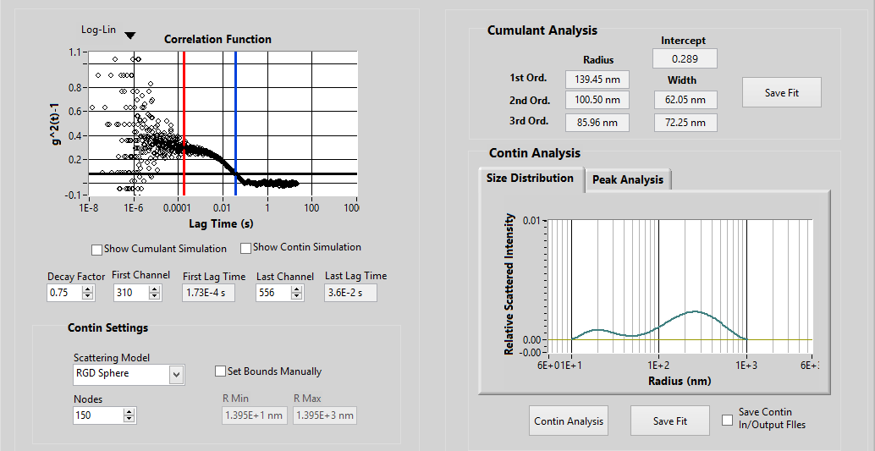

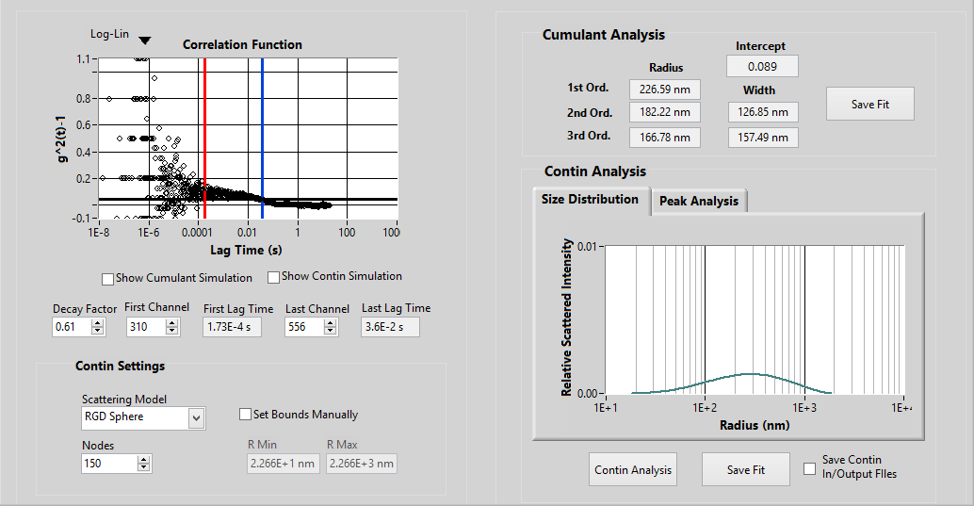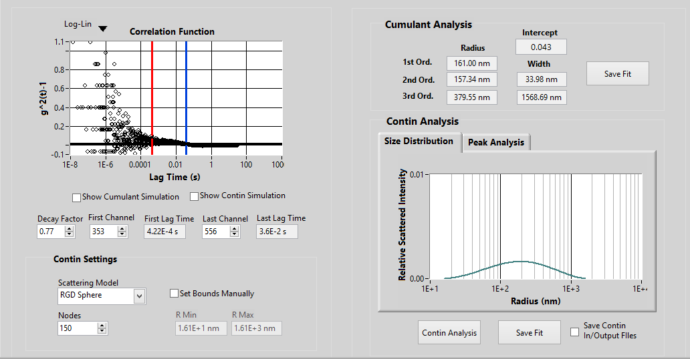

*Figure 9: From top left to bottom right: CONTIN analysis plots at 100 degrees scattering angle for 1%, .5%, .1%, .01%, and .001% by weight of 039-2 samples*

CONTIN analysis shows tenatively that the monodispersity decreases as concentration increases, similar to the 039-5 samples. For all of the DLS measurements corresponding to these CONTIN fits, the intercepts were low, meaning that much of the signal was noise. The CONTIN model may have overfit the data by fitting the noise. They indicate the possible formation of aggregates, but this data is by no means conclusive.

DISCUSSION/PLANS

Our hypothesis is that the functionalized group added to the polymer chain allows the polymer to form a micelle or some other sort of aggregate in the oil samples. As discussed in the introduction, both ends of the block copolymer are hydrophobic, so for the 039-2 sample, we do not expect the formation of micelles, although the polymer may form another sort of aggregate.

Figure 6 shows us that for the 039-5 sample, the average hydrodynamic radius does not vary more than 50 nm in the measured concentration range, but it does roughly increase with concentration. This may be an indication that the size and number of aggregates increases as concentration increases. Because hydrodynamic radius is an average, the presence of more aggregates would increase the reported particle size, even if the size of the aggregates themselves did not increase. At the lower concentrations in the range, the percentage of aggregates is likely lower than at the higher concentrations. However, the particle size may be reported as somewhat similar because large particles have such a great effect on the average hydrodynamic radius.

For the 039-5 sample, CONTIN analysis, along with the width of the distribution, tells us something about the dispersity of the sample. Figure 7 shows that the number of peaks decreases as concentration decreases. The width of the distribution follows a similar trend, getting narrower at lower concentrations. This seems to indicate that as concentration rises, the sample becomes less monodisperse. One possibility is that as concentration increases, the number of different populations of aggregates increases, hence more peaks in the CONTIN fit. We can tentatively guess that the critical micelle concentration for the 039-5 is between .01% and .1% by weight, although more rigorous analysis and further measurement repetitions could confirm this.

The data for the 039-2 sample is far less reliable, and this may be because of the small particle size and the high amount of noise. However, there is slight evidence that the non-functionalized polymer forms aggregates as well. It is clear, though, that the addition of the functionalized group to the chain has an effect on the aggregation behavior of the polymer.

Although only guesses can be made at this point due to lack of data and experimental rigor, it seems that the functionalized group allows the polymer to form an aggregate that may be a micelle. The reason that this could be a micelle is that the sample transitions from being monodispersed to being polydispersed from .01% to .1% concentration by weight. This resembles the behavior of a surfactant; at a certain concentration (the CMC), the surfactant transitions from forming a surface layer to forming micelles in the solution. There is a possibility that this process is happening with the 039-5 sample. As mentioned, it is unlikely that the 039-2 sample would form a micelle, given its chemical structure. However, further research could show that the 039-2 forms another type of aggregate.

The continuation of this research would involve further DLS measurements to more precisely determine the CMC, as well as CONTIN analysis that allows for the manipulation of model parameters. It would require further study of aggregation and self-assembly that would allow us to form a hypothesis of how the 039-2 sample will behave. It is also necessary to measure these samples at a greater concentration range to see if trends persist. For sample preparation, it may be helpful to find an alternative way to dissolve the polymer so there is no chance that remaining THF will effect on the measurements. This semester’s research is just a start to this project, and experimentation, further research, and use of alternative techniques will hopefully reveal significant information about these polymers.

1. HIRST, LINDA S. FUNDAMENTALS OF SOFT MATTER SCIENCE. CRC PRESS, 2018., pages 14-15
2. Hirst, 99-100
3. Hirst, 106-107
4. Image: https://www.quora.com/What-are-micelles
5. Hirsch, 78-82
6. “Dynamic Light Scattering: Measuring the Particle Size Distribution.” Lsinstruments.com, LS Instruments, www.lsinstruments.ch/technology/dynamic_light_scattering_dls/., Berne, Bruce J., and Robert Pecora. Dynamic Light Scattering: with Applications to Chemistry, Biology, and Physics. Dover Publications, 2000.
7. “Common Terms Used In Dynamic Light Scattering.” AZoM.com, Malvern Panalytical, 19 Jan. 2018, www.azom.com/article.aspx?ArticleID=9924#9.